**SILVER OAK COLLEGE OF ENGINEERING & TECHNOLOGY /**

**ADITYA SILVER OAK INSTITUTE OF TECHNOLOGY**

**DEPARTMENT OF INFORMATION TECHNOLOGY/**

**DEPARTMENT OF COMPUTER ENGINEERING**

A Report on

**<Airport Management>**

Under Subject of

**Innovation and Design Thinking - II**

Semester - IV

[Department of Information Technology]

***Submitted by***

# **<Suthar Meet><2202031000148>**

# **<Prajapati Dhruv><2202031000167>**

# **<Rana Dev><2202031000133>**

# **<Patel Karan><2202031000160>**

# **<Patel Vansh><2202031000120>**

**<Davda Jainam><2202031030135>**

**ACKNOWLEDGEMENT**

We are heartily thankful to our supervisor, **Guide name,** whose encouragement, supervision and support from the preliminary to the concluding level enabled me to develop an understanding of the subject. At the end, we offer my regards and blessings to all of those who supported us in any respect during the completion of the project and to our college for providing a resources and materials.

We would like to extend my gratitude to **HOD (Name)**, Head of **Information Technology / Computer Engineering** Department, Silver Oak college of Engineering and Technology, Ahmedabad, for his continuous encouragement and motivation.

Last but not the least we would like to mention here that we are greatly indebted to each and everybody who has been associated with our project at any stage but whose name does not find a place in this acknowledgement.

Yours Sincerely,

**Patel karan (2202031000160)**

**ABSTRACT**

The Airport Management System (AMS) is an essential component in ensuring the smooth operation of airports worldwide. In this abstract, we present a comprehensive overview of an advanced AMS designed to streamline airport operations, enhance passenger experience, and optimize resource allocation.

The AMS encompasses various modules, each catering to different aspects of airport management. Firstly, the passenger management module focuses on facilitating seamless passenger flow from check-in to boarding, employing advanced technologies such as self-service kiosks, biometric authentication, and automated baggage handling systems. This module aims to reduce wait times, enhance security, and improve overall traveler satisfaction.

Secondly, the flight management module monitors and coordinates all flight-related activities, including scheduling, gate assignment, and aircraft turnaround. By leveraging real-time data analytics and predictive modeling, this module optimizes resource utilization, minimizes delays, and maximizes operational efficiency.

Furthermore, the resource management module oversees the allocation of airport resources, such as gates, runways, and ground handling equipment, in a dynamic and cost-effective manner. Through intelligent scheduling algorithms and proactive maintenance planning, this module ensures optimal utilization of infrastructure and minimizes downtime.

Additionally, the security management module implements robust security protocols and surveillance systems to safeguard airport facilities, personnel, and passengers against potential threats. By integrating with national security databases and employing advanced screening technologies, this module enhances situational awareness and threat detection capabilities.

Moreover, the revenue management module facilitates the monetization of airport services and amenities through dynamic pricing strategies, loyalty programs, and targeted advertising. By analyzing passenger behavior and market trends, this module maximizes non-aeronautical revenue streams while maintaining competitiveness in the aviation market.

**LIST OF FIGURES**

|  |  |  |
| --- | --- | --- |

| **Figure No.** | **Figure Name** | **Page No.** |
| --- | --- | --- |





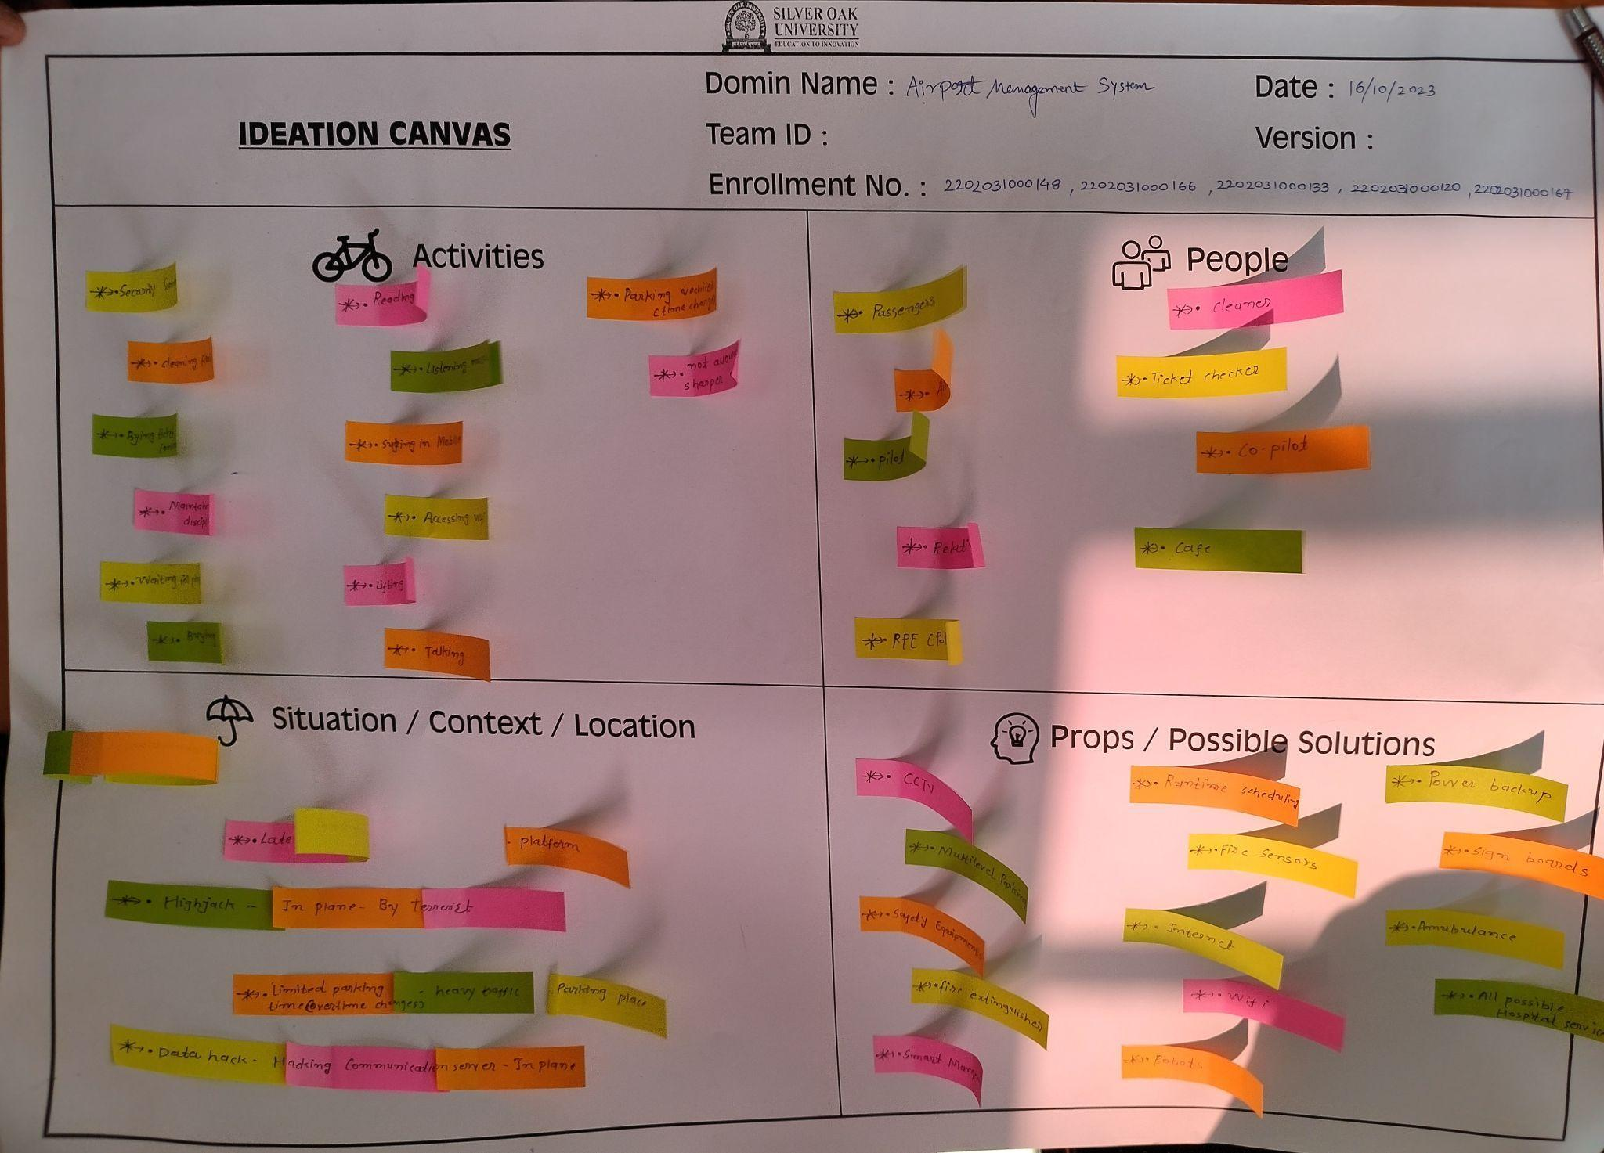

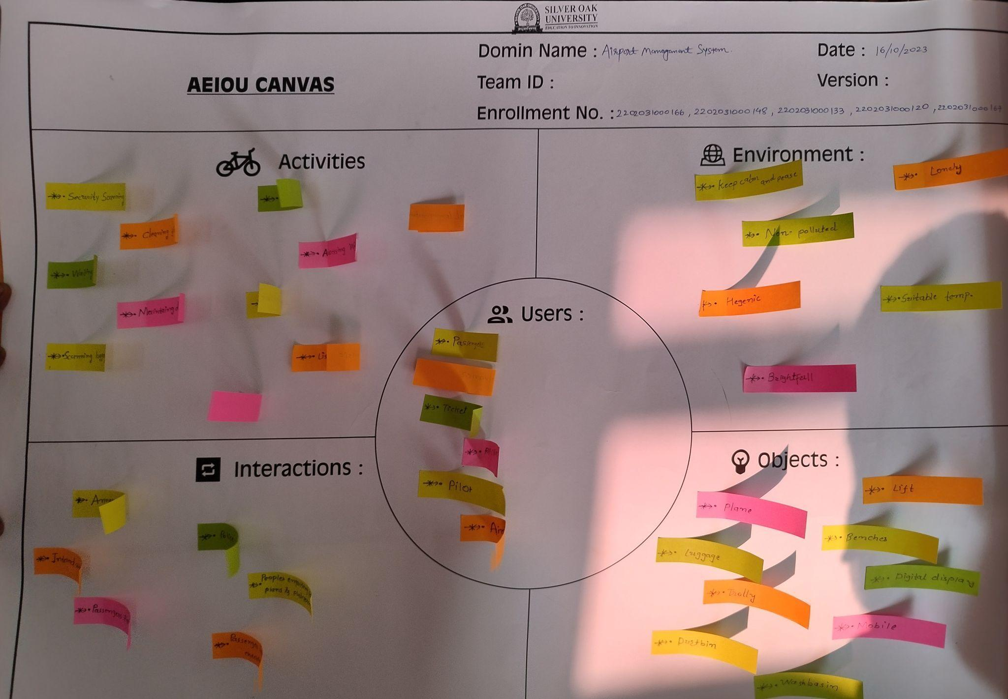

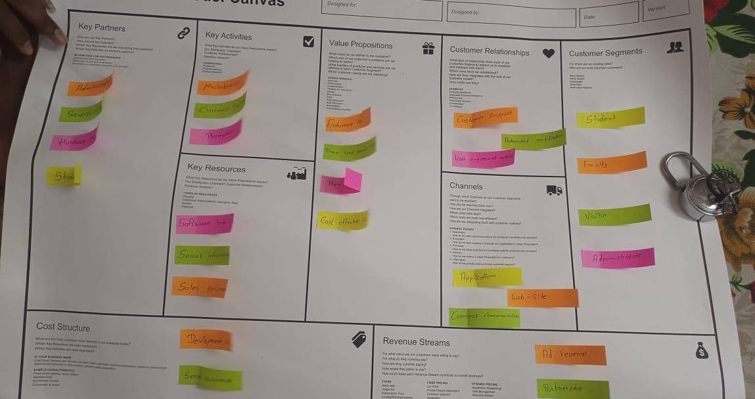

**LIST OF FIGURES**

| **Figure No.** | **Figure Name** |
| --- | --- |
| **1** | **AEIOU Framework** |
| **2** | **Mind Map** |
| **3** | **Ideation canvas** |
| **4** | **Rough prototype model / Conceptual plan - layout** |
| **5** | **Empathy Canvas** |
| **6** | **Product Development Canvas** |

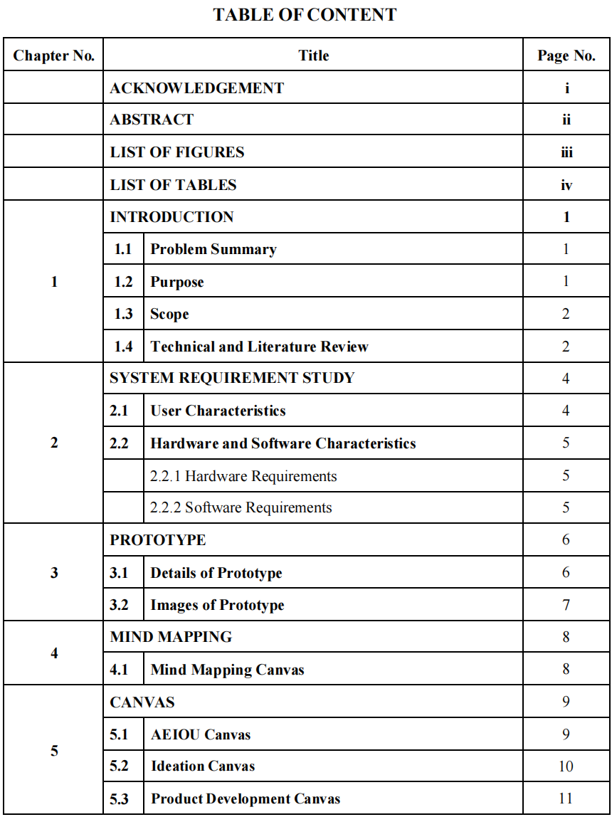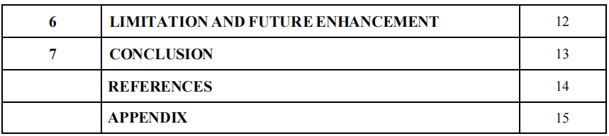

**Introduction**

In the dynamic world of aviation, efficient management of airport operations is paramount for ensuring smooth travel experiences and maintaining safety standards. An Airport Management System (AMS) serves as the backbone of airport operations, integrating various functionalities to streamline processes, enhance security, and optimize resource utilization.

At its core, an AMS encompasses a suite of software applications and hardware infrastructure designed to manage diverse aspects of airport activities. From passenger check-in and baggage handling to aircraft scheduling and air Airportcontrol coordination, an AMS orchestrates the intricate dance of activities that enable airports to function seamlessly.

Key components of an AMS typically include:

Passenger Management: Facilitating smooth passenger flow from check-in to boarding gates, including ticketing, security checks, and boarding procedures.

Baggage Handling: Ensuring efficient tracking, sorting, and transfer of luggage to minimize delays and enhance passenger satisfaction.

Flight Operations: Coordinating aircraft scheduling, gate assignments, and ground handling services to optimize resource allocation and minimize turnaround times.

Security and Safety: Implementing robust security protocols, including passenger screening, access control, and emergency response systems, to safeguard passengers, staff, and assets.

Resource Allocation: Managing airport infrastructure, such as runways, taxiways, and terminal facilities, to maximize utilization and minimize congestion.

Revenue Management: Optimizing commercial opportunities, such as retail concessions, advertising space, and parking facilities, to generate additional revenue streams for the airport.

Data Analytics: Leveraging data analytics and predictive modeling to identify trends, anticipate demand, and enhance operational efficiency.

By integrating these components into a cohesive system, an AMS empowers airport authorities to enhance operational efficiency, improve passenger experiences, and adapt to evolving industry trends and regulatory requirement

**Problem statement:**

**\*Baggage Handling Delays:\*** Inefficient baggage handling processes can lead to delays in luggage delivery, causing inconvenience to passengers and potentially impacting flight schedules.

**\*Flight Schedule Disruptions:\*** Unforeseen events such as adverse weather conditions, airspace congestion, or technical issues can disrupt flight schedules, leading to delays and cancellations

**\*Long Queues at Security Checkpoints:\*** Lengthy queues at security checkpoints can result in passenger dissatisfaction, increased wait times, and congestion within terminal areas.

**\*Inefficient Ground Transportation:\*** Inadequate ground transportation infrastructure or inefficient operations can lead to congestion, delays, and difficulty accessing the airport.

**\*Lack of Passenger Information:\*** Insufficient or outdated information provided to passengers regarding flight status, gate changes, or amenities within the airport can lead to confusion and frustration.

**Solution statement**

**Solution for** **Baggage Handling Delays:**Implement Automated Baggage Handling Systems: Automated systems can streamline the baggage handling process by utilizing barcode or RFID technology to track luggage throughout its journey, from check-in to loading onto the aircraft. These systems can significantly reduce the risk of mishandled baggage and improve overall efficiency in baggage operations.

**Solution for Flight Schedule Disruptions:**Utilize Predictive Analytics: Predictive analytics software can analyze historical flight data, weather patterns, and other relevant factors to forecast potential disruptions in flight schedules. By providing early warnings and recommending proactive measures, airlines and airport authorities can minimize the impact of disruptions and better manage resources to maintain operational continuity.

**Solution for Long Queues at Security Checkpoints:**Implement Advanced Security Screening Technologies: Advanced security screening technologies, such as automated body scanners and advanced imaging systems, can enhance the efficiency of security checkpoints by reducing the need for manual inspections and accelerating the screening process. Additionally, adopting strategies such as dedicated lanes for passengers with TSA PreCheck or trusted traveler status can further expedite security screening for eligible passengers, alleviating queues and improving overall passenger flow.

**Solution for Inefficient Ground Transportation:**Invest in Public Transportation Integration: Collaborating with local transportation authorities to improve connectivity between the airport and surrounding areas through public transportation options, such as buses, trains, or light rail, can help alleviate traffic congestion and reduce reliance on personal vehicles. Additionally, implementing smart parking management systems and providing real-time information on parking availability can enhance the overall efficiency of ground transportation services and improve the passenger experience.

**Solution for Lack of Passenger Information:**Deploy Digital Passenger Information Displays: Installing digital signage and information displays throughout the airport terminals can provide real-time updates on flight status, gate assignments, boarding announcements, and other relevant information to passengers. Additionally, developing a user-friendly airport mobile app or website that offers personalized travel assistance, wayfinding services, and interactive maps can empower passengers to navigate the airport more efficiently and stay informed throughout their journey.

**Purpose of Airport Management**

An airport management system serves as the operational backbone of an airport, orchestrating a myriad of functions to ensure seamless operations, safety, and customer satisfaction. By integrating flight scheduling, resource allocation, passenger management, and security protocols, these systems optimize the utilization of airport facilities and personnel. Through real-time data analysis and efficient communication channels, they enable timely decision-making and response to dynamic operational challenges. Ultimately, the purpose of an airport management system is to uphold operational excellence, regulatory compliance, and the highest standards of service delivery within the aviation industry.

**Cause of Airport Management**

The emergence and adoption of airport management systems can be attributed to several key factors driving the need for efficient and streamlined airport operations.

Rising Air Traffic: With the exponential growth in air travel demand globally, airports face increasing pressure to handle larger volumes of passengers, flights, and cargo. Airport management systems help manage this influx by optimizing resources and processes to accommodate growing Airportwhile maintaining operational efficiency.

Complexity of Operations: Modern airports are complex ecosystems involving numerous stakeholders, including airlines, ground handlers, security agencies, and retail operators. Coordinating these diverse activities requires sophisticated management tools to ensure seamless integration and collaboration across different functions.

Safety and Security Concerns: Ensuring the safety and security of passengers, aircraft, and airport facilities is paramount in the aviation industry. Airport management systems play a crucial role in implementing and monitoring security protocols, managing emergency response procedures, and enhancing overall safety standards.

Customer Experience: In an increasingly competitive aviation market, airports strive to enhance the passenger experience to attract and retain customers. Efficient airport management systems facilitate smooth passenger flow, minimize wait times, and provide timely information and services, contributing to overall customer satisfaction.

**Technical and literature review**

A technical and literature review for airport management would typically encompass various aspects related to airport operations, technology implementation, and academic research. Here's an outline:

Introduction to Airport Management: Provide an overview of airport management and its significance in ensuring efficient and safe airport operations. Highlight the challenges faced by airport managers in handling increasing air traffic, passenger expectations, and regulatory requirements.

Airport Management Systems: Review the different types of airport management systems, including Airport Operational Database (AODB), Airport Collaborative Decision Making (A-CDM), Airport Information Management System (AIMS), and Airport Resource Management System (ARMS). Discuss their functionalities, integration with other systems, and benefits for airport operations.

Technology Trends in Airport Management: Explore emerging technologies such as artificial intelligence (AI), Internet of Things (IoT), blockchain, and data analytics, and their applications in airport management. Discuss how these technologies are transforming various aspects of airport operations, including passenger processing, security screening, and predictive maintenance.

Case Studies and Best Practices: Analyze case studies of airports that have successfully implemented innovative management practices or technology solutions to improve efficiency, safety, and passenger experience. Identify best practices and lessons learned from these case studies that can be applied to other airports.

Safety and Security in Airport Management: Review literature on safety and security challenges in airport management and discuss strategies for mitigating risks, enhancing security measures, and ensuring compliance with regulatory standards.

Environmental Sustainability: Discuss the growing importance of environmental sustainability in airport management and explore initiatives aimed at reducing carbon emissions, noise pollution, and waste generation. Review research on green technologies, renewable energy solutions, and sustainable airport design and operations.

Passenger Experience and Service Quality: Examine research on passenger satisfaction, preferences, and behavior in airport environments. Discuss strategies for improving the passenger experience, including wayfinding systems, digital signage, self-service technologies, and personalized services.

Future Directions and Research Opportunities: Identify emerging trends, challenges, and research gaps in airport management and suggest potential areas for future research. Discuss the implications of technological advancements, regulatory changes, and evolving passenger expectations on the future of airport management.

**System Reqirement Study**

Conducting a System Requirement Study (SRS) for airport management is critical for understanding the needs and specifications of the system to be developed or implemented. Here's how it can be summarized in 8 marks:

1. Identifying Stakeholders:
   * Airport authorities, airlines, ground handlers, security agencies, retail operators, and passengers are key stakeholders.
2. Gathering Requirements:
   * Conduct interviews, workshops, and surveys to capture functional and non-functional requirements.
3. Functional Requirements:
   * Include flight operations, passenger management, resource allocation, safety and security, revenue management, and information management.
4. Non-Functional Requirements:
   * Encompass performance, security, reliability, usability, compatibility, and maintainability aspects.
5. System Architecture:
   * Define the high-level architecture considering scalability, modularity, and integration with existing systems.
6. Data Requirements:
   * Identify the types of data to be managed and define data formats, storage requirements, and exchange protocols.
7. Constraints and Assumptions:
   * Document budgetary constraints, regulatory requirements, and technological limitations that may impact the system design.
8. Validation and Documentation:
   * Review requirements with stakeholders, validate against industry standards, and compile into a comprehensive System Requirement Document (SRD).

**Details prototype**

Define Key Features:

Identify the core features and functionalities of the Airport management system you want to prototype. This could include real-time Airport monitoring, Airport signal control, incident detection, data visualization, and user interaction.

Choose a Prototyping Tool:

Select a prototyping tool or platform that suits your needs. This could be a software tool like Axure, Sketch, Adobe XD, Figma, or even a combination of HTML/CSS/JavaScript for web-based prototypes.

Design User Interfaces (UI):

Create wireframes or mockups of the user interfaces for different components of the Airport management system, such as a dashboard for Airportoperators, a control panel for signal controllers, and a mobile app for commuters.

Implement Basic Functionality:

Use the prototyping tool to add basic functionality to the UI components. For example:

Simulate real-time Airportdata updates on the dashboard.

Allow the user to change Airport signal timings and see the impact on Airport flow.

Display alerts and notifications for incidents detected in the system.

Add Interaction and Navigation:

Define interactive elements such as buttons, sliders, checkboxes, and dropdown menus to simulate user interactions.

Create navigation flows between different screens or modules of the Airport management system.

Incorporate Simulated Data:

Integrate simulated data sources or APIs to populate the prototype with realistic Airportdata. This could include Airport flow

**Mind Mapping Canvas**

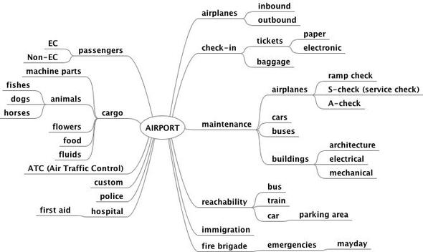

**Limitations of Current Airport Management :**

Current airport management systems, while highly sophisticated, still face several limitations that hinder their ability to fully meet the evolving needs of airports and passengers. Here are some key limitations:

1. **Limited Scalability**:

- Traditional airport management systems may struggle to scale effectively to accommodate increasing air traffic and passenger volumes. This can lead to congestion, delays, and inefficiencies in airport operations during peak times.

2. **Data Silos and Lack of Integration**:

- Data silos often exist within airport management systems, limiting the ability to access and share real-time information across different stakeholders and departments. This can impede collaboration and decision-making processes.

3. **Security Vulnerabilities**:

- Airport management systems are prime targets for cyberattacks due to the sensitive nature of the data they handle, including passenger information, flight schedules, and security protocols. Security vulnerabilities in these systems pose a significant risk to airport operations and passenger safety.

4. **Limited Passenger Experience**:

- While airport management systems focus on operational efficiency, they may fall short in delivering a seamless and personalized passenger experience. Long wait times, cumbersome security procedures, and lack of real-time information can detract from the overall passenger experience.

5. **Regulatory Compliance Challenges**:

- Ensuring compliance with evolving aviation regulations and standards can be a complex and time-consuming process for airport management systems. Keeping up with regulatory changes and implementing necessary updates poses challenges for system administrators.

6. **Dependency on Manual Processes**:

- Despite advancements in automation, many airport management systems still rely on manual processes for tasks such as baggage handling, security screening, and passenger check-in. This can lead to inefficiencies, errors, and delays in airport operations.

7. **Environmental Impact**:- Traditional airport management systems may not prioritize environmental sustainability in their operations. This can contribute to carbon emissions, energy consumption, and waste generation, negatively impacting the environment.

**Future Enhancements in Airport Management:**

Future enhancements in airport management will likely focus on leveraging advanced technologies to address current limitations, improve operational efficiency, enhance passenger experience, and ensure sustainability. Here are some potential future enhancements:

1. **Predictive Analytics and AI**:

- Implement predictive analytics and artificial intelligence (AI) algorithms to forecast passenger traffic, optimize resource allocation, and anticipate operational bottlenecks. AI can also be used for predictive maintenance of airport infrastructure and equipment, reducing downtime and improving efficiency.

2. **Smart Infrastructure and IoT**:

- Deploy Internet of Things (IoT) sensors and smart infrastructure to monitor airport facilities, such as runways, terminals, and parking lots, in real-time. This data can be used to optimize maintenance schedules, improve energy efficiency, and enhance safety and security.

3. **Biometric Identification and Seamless Travel**:

- Expand the use of biometric identification technologies, such as facial recognition and fingerprint scanning, to streamline passenger processing and enable seamless travel experiences. Biometric authentication can be integrated into various touchpoints, including check-in, security screening, and boarding gates.

4. **Augmented Reality (AR) and Virtual Reality (VR)**:

- Utilize AR and VR technologies to provide immersive experiences for passengers, airport staff, and stakeholders. AR applications can assist passengers with wayfinding, baggage tracking, and personalized recommendations, while VR simulations can be used for training staff and conducting virtual inspections of airport facilities.

5. **Blockchain for Security and Transparency**:

- Implement blockchain technology to enhance security, transparency, and traceability in airport operations. Blockchain can be used to secure passenger data, track the movement of goods and assets, and streamline processes such as aircraft maintenance and supply chain management.

6. **Robotic Automation and Drones**:

- Introduce robotic automation and drones for various tasks within the airport, including cleaning, maintenance, and security patrols. Robotic systems can assist with baggage handling and aircraft servicing, while drones can be used for perimeter surveillance and infrastructure inspections.

7. **Personalized Passenger Services**:

- Develop personalized passenger services and amenities based on data analytics and passenger preferences. This may include tailored retail offers, concierge services, and digital assistants that provide real-time information and assistance throughout the journey.

8. **Environmental Sustainability Initiatives**:

- Prioritize environmental sustainability initiatives by implementing green technologies, renewable energy sources, and eco-friendly practices throughout airport operations. This includes reducing carbon emissions, minimizing waste generation, and conserving natural resources.

By embracing these future enhancements, airports can become more efficient, resilient, and passenger-centric while minimizing their environmental footprint and contributing to a sustainable aviation industry.

**Conclusion on Airport management**

In conclusion, airport management plays a pivotal role in ensuring the efficient and safe operation of airports while delivering a seamless travel experience for passengers. As the aviation industry continues to evolve, airport management faces a myriad of challenges and opportunities.

Efforts to modernize airport management systems and adopt innovative technologies are essential to address current limitations and meet the evolving needs of airports, airlines, and passengers. From predictive analytics and artificial intelligence to biometric identification and blockchain, the future of airport management is poised to be characterized by advanced solutions that enhance operational efficiency, security, and sustainability.